Chapter 7, Problem 60.

Find v(t) for t > 0 in the circuit of Fig. 7.125 if the initial current in the inductor is zero.

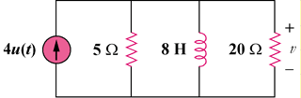

Figure 7.125
For Prob. 7.60.

